Milestone 1
CST-391
Chris Peterson

The idea for my milestone project is a database of sermons, tagged and organized for download. The sermons would be uploaded at the admin side while the general user can pick and download whatever they want.

As a visitor, I want to browse sermons by category so that I can find topics that interest me.
As a user, I want to search sermons by keyword, speaker, or scripture reference so that I can quickly locate relevant content.
As a user, I want to filter sermons by date, length, or topic so that I can narrow down my choices.
As a user, I want to download sermons from the website and listen to them offline, or stream them straight from the site.
As an Admin, I want do upload sermons to the database and add tags that the user finds useful, such as the date, length, and topic.

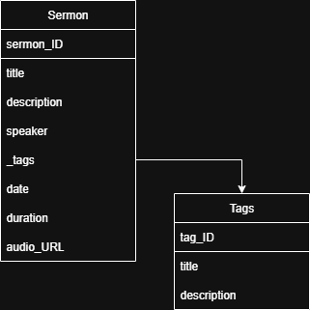
ER Diagram

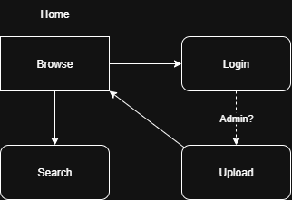
Site Diagram
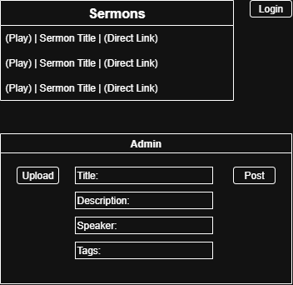
Wireframe

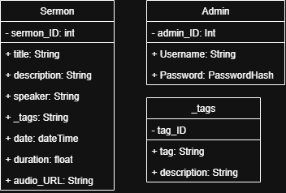
UML Diagrams

